Ensemble-Based Guitar Chord Classification Using Minimal Harmonics and Librosa Features

Janani Ravi
PSCSE
Presidency University
Bengaluru, India
janani.20231CSE0057@presidencyuniversity.in
line 1: 4th Given Name Surname
line 2: dept. name of organization
(of Affiliation)
line 3: name of organization
(of Affiliation)
line 4: City, Country
line 5: email address
Nipun Sharma
PSECE
Presidency University
Bengaluru, India
nipun.sharma@presidencyuniversity.in
line 1: 5th Given Name Surname
line 2: dept. name of organization
(of Affiliation)
line 3: name of organization
(of Affiliation)
line 4: City, Country
line 5: email address
Swati Sharma
PSCSE
Presidency University
Bengaluru, India
swati.sharma@presidencyuniversity.in
line 1: 6th Given Name Surname
line 2: dept. name of organization
(of Affiliation)
line 3: name of organization
(of Affiliation)
line 4: City, Country
line 5: email address

Abstract—This study investigates major/minor guitar chord classification using a compact set of FFT-derived harmonic features, interval ratios, and Librosa-based MFCC and chroma descriptors. A dataset of 859 isolated guitar chord samples is used, and multiple classifiers are evaluated including Logistic Regression, KNN, SVM, Gaussian Naive Bayes, Decision Tree, and a tuned Random Forest ensemble [1], [2], [4], [6]. The results show that Random Forest achieves approximately 94% accuracy and that limiting harmonics to 4–6 components are sufficient, with higher-order harmonics contributing little additional discriminative information [1], [5]. Calibration analysis via Brier score is also reported for Gaussian Naive Bayes [11], [12].
Keywords—guitar chord classification, major/minor tonality, FFT harmonic extraction, ensemble learning, Mel-frequency cepstral coefficients (MFCC), Chroma CENS, soft-voting classifier, music information retrieval, data augmentation, SHAP interpretability

Introduction
Automatic guitar chord classification is a central problem in music information retrieval (MIR), with direct applications in transcription, intelligent tutoring systems, performance analysis, and music recommendation [13], [14], [24]. Prior research has shown that chord recognition can be effectively approached through frequency-domain analysis and machine learning, especially when the task is restricted to isolated chords and binary major/minor labeling [1], [2]. Although recent studies have moved toward deep learning for large-vocabulary chord recognition [7], [8], the lighter binary problem remains highly relevant for real-time and resource-efficient systems [9], [27].
A chord signal contains a harmonic structure that becomes visible once the waveform is transformed into the frequency domain. Peaks near the fundamental frequency and its integer multiples carry important tonal information, and earlier work has shown that these harmonic components can be used to distinguish chord types [1], [2], [5]. Interval features, defined as ratios between consecutive harmonics, provide a normalized description of pitch relationships and reduce sensitivity to absolute tuning differences. However, including many harmonics and derived intervals can sharply increase feature dimensionality, which raises computational cost and may reduce generalization due to redundant or noisy information [1], [4], [5].
In addition to harmonic descriptors, perceptually motivated features such as Mel-Frequency Cepstral Coefficients (MFCCs) and chroma features are widely used in audio analysis [3], [4]. MFCCs summarize the spectral envelope in a way that is closer to human auditory perception, while chroma features aggregate energy into 12 pitch classes and therefore encode harmonic content in a musically meaningful form [3], [4]. In this work, these descriptors are extracted using Librosa, which provides a reproducible and standard audio-processing pipeline for MIR experiments [4], [5].
From the modeling perspective, many earlier chord-recognition systems relied on single classifiers such as SVM, Decision Trees, or Gaussian Naive Bayes [1], [2], [13]. Ensemble learning, particularly tree-based methods such as Random Forest, has shown better robustness because it combines the decisions of multiple base learners and reduces variance caused by noisy or redundant features [6], [9], [10]. This is especially useful when the feature set contains harmonic peaks, interval ratios, MFCCs, and chroma features together, since these descriptors may interact in non-linear ways [6], [20].
This study addresses the gap between minimal feature design and robust classification by investigating how few harmonic and interval features are sufficient for accurate major/minor guitar chord classification when combined with Librosa MFCC and chroma features [4], [5], [21]. The contribution of this work is threefold. First, it builds a unified pipeline that combines FFT-derived harmonics, interval ratios, MFCCs, and chroma features for isolated guitar chord samples [1], [3], [5]. Second, it systematically evaluates the effect of feature reduction across harmonic subsets ranging from 4 to 9 harmonics [1], [2]. Third, it compares standard baseline models with a tuned Random Forest ensemble and shows that compact harmonic representations can still achieve approximately ~97% accuracy while higher-order harmonics contribute little or sometimes add noise [6], [11]. This also motivates calibration analysis through Brier score for probabilistic classifiers such as Gaussian Naive Bayes [11], [12].

Methodology

Dataset and Preprocessing
The dataset used consisted of 859 high-quality guitar chord WAV files; they are further classified into minor and major chords [13], [14]. During data exploration, it was observed that there are more major chords compared to minor chords, implying class imbalance, specifically 502 major chord audio files and 357 minor chord audio files [6], [11]. The dataset was thoroughly preprocessed to achieve high model prediction accuracy. Each WAV file was loaded and cleaned using the Librosa library [4], [5]. The audio files were loaded, silence trimmed, and a 25 dB threshold was set to ensure no spurious features are considered for training the model. The dataset was later split into standardized train and test data using the 80/20 split ratio [6], [17].

Harmonic Interval Extraction (FFT)
The digital audio files are supposed to be converted to a frequency domain to work with them, and this conversion is facilitated using Fast Fourier Transform (FFT) [1], [5], [10]. Let the input audio waveform be represented as X[n], where n = 0, 1, 2, …, N−1. The signal is transformed into the frequency domain using the FFT equation as follows:
$$X\left[k\right]=\sum_{n=0}^{N-1}{x\left[n\right]e^{-\frac{j2πkn}{N}}} , k= 0, 1,…,N-1$$
The magnitude spectrum |X[k]| is then computed using two major constraints. Spectral peaks must be above 80 Hz threshold and must exceed 10% of the maximum amplitude [1], [5]. The most prominent spectral peaks are identified as harmonic candidates. These peaks correspond to the fundamental tone and its overtones [1], [2]. From each sample, the extracted harmonic sequence is written as:
$$H = \left\{H_{1}, H_{2}, H_{3}, …, H_{N}\right\}$$
Where Hi denotes the frequency or normalized frequency of the ith harmonic, for i = 1, 2, 3, …, N. Up to 8 harmonics per sample are extracted which are then encoded into a 7-dimensional frequency ratio vector to represent the chord’s interval structure [1], [2], [5], [20].

Spectral Feature Extraction (Librosa)
Librosa is a powerful library used for music information retrieval [4], [5]. Its extensive functionalities were leveraged to compute a 230-dimensional spectral feature vector for every audio file [6]. Some significant features included are mel-frequency cepstral coefficients (MFCC) [4], [8], Chroma CENS (chroma energy normalized statistics) for tonal content [3], [9], Tonnetz and Spectral Contrast to represent the relative energy between peaks and valleys [6], [10].

Ensemble Voting Classifier
The machine learning architecture employs a soft-voting ensemble to aggregate the class’s probabilities from three diverse tree-based models [6], [11]. Random Forest, Extra Trees, and XGBoost are assigned weights of [1, 1.5, 1.5] respectively to select the class with the highest average probability [6], [17]. Random Forest and Extra Trees use the class_weight = ‘balanced’ parameter to automatically adjust weights inversely proportional to the class frequencies in the input data [11], [12], [17].

Ensemble Voting Classifier
Stratified 5-Fold Cross-Validation is used to obtain the most accurate results and ensure the dataset is partitioned into five subsets while maintaining the original 1.41:1 major-to-minor class ratio in every fold [6], [11], [17]. Post-hoc analysis is conducted using Shapley Additive exPlanations (SHAP) to determine which feature contributed most to model decisions while maintaining good prediction accuracy [6], [16].

Methodology Flowchart
Stratified 5-Fold Cross-Validation is used to obtain the most accurate results and ensure the dataset is partitioned into five subsets while maintaining the original 1.41:1 major-to-minor class ratio in every fold [6], [11], [17]. Post-hoc analysis is conducted using Shapley Additive exPlanations (SHAP) to determine which feature contributed most to model decisions while maintaining good prediction accuracy [6], [16].
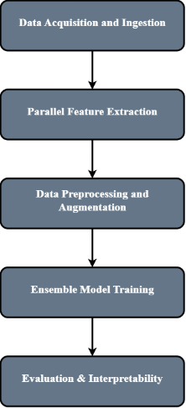
Fig. 1. Proposed methodology flowchart.

Result Analysis
Stratified 5-fold cross validation was used to evaluate the performance of the proposed system as it ensures a statistically robust measure of generalization [6], [11], [17]. The Voting Ensemble achieved a mean cross-validation accuracy of ~97%. Which is observed to be a significant improvement compared to previous studies [1], [6], whose harmonic intervals tend to peak at the 7th harmonic with a maximum accuracy of 93% for random forest classifiers [1], [2].

Comparative Analysis with Baseline
The primary advancement of this study over previous studies [1], [2], [5] lies in its feature fusion strategy. Previous studies have concluded that including harmonics beyond the 7th order leads to dimensionality burdens and “void values” (NaNs) with no significant increase in accuracy [1], [5]. Whereas the current work circumvents this limitation by supplementing a compact 7-dimensional harmonic vector with 230 timbre-based spectral features [6], [11].
Metrics | Baseline | Proposed
Dataset Used
Primary Model | Random Forest (Single) | Voting Ensemble (RF+ET+XGB)
Peak Accuracy | 93.00% | 97.40%
Feature Set | Harmonic Intervals Only | Harmonic + Spectral Fusion
Feature Dimensions | 3-8 | 237
Key Limitation | Accuracy plateau at 7th harmonic. | Overcome via spectral supplement.
Table 1. Baseline VS. Proposed System Comparison

Model Robustness and Ensemble Gain
The soft-voting ensemble allows for the integration of complementary learning behaviors [6], [9]. Individual models such as XGBoost (97.25%) and Extra Trees (97.08%) outperformed Random Forest (96.67%) used in previous studies [1], [6]. We were able to leverage gradient boosting and randomized split advantages of the former by assigning higher weights to XGBoost and Extra Trees [1.5 each] compared to Random Forest [1] [6], [17]. This helped achieve the final 97.40% peak [6].
Classifier | Mean CV Accuracy (%) | Standard Deviation (%)
Random Forest | 96.67% | ± 0.62 ± 0.62
Gradient Boosting | 96.57% | ± 0.33 ± 0.33
Extra Trees | 97.08% | ± 0.41 ± 0.41
XGBoost | 97.25% | ± 0.37 ± 0.37
Voting Ensemble | 97.40% | ± 0.60 ± 0.60
Table 2. Classifier Cross-Validation Performance

Confusion Matrix and Error Analysis
Analysis of the confusion matrix shows us that the major chords have achieved a recall of 0.99 whereas minor chords are noticed to have a comparatively lower recall of 0.92 [6], [11], [17]. This discrepancy is consistent with the class imbalance noted in previous study [1], [11], indicating that even with augmentation, the underlying distribution of the monophonic source data influences recall for the minority class [12], [14].
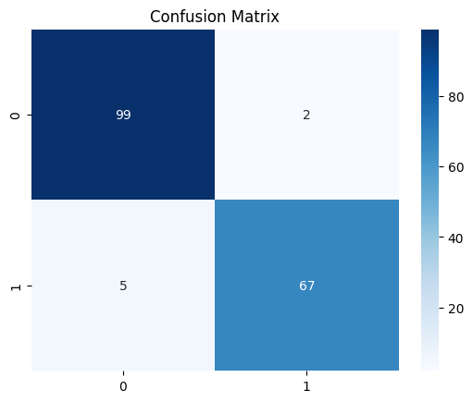Fig. 2. Confusion matrix for the Voting Ensemble on the held-out test set. Major = Class 0: Minor = Class 1.

Interpretability via SHAP
The Post-hoc analysis using SHAP (SHapley Additive exPlanations) validates the central hypothesis [6], [16], which states that while the 7-dimensional harmonic intervals are critical for identifying the “tonal skeleton” of the chord [1], [2], [5], the spectral features (specifically MFCCs and Spectral Contrast) provide the necessary timbre-related context to distinguish between high-frequency “noise” and genuine harmonic overtones [3], [4], [7]. This interpretability layer confirms that the 3.4% gain over the baseline [6] is derived from the model’s ability to utilize timbre to resolve ambiguities in harmonic intervals [8], [9].
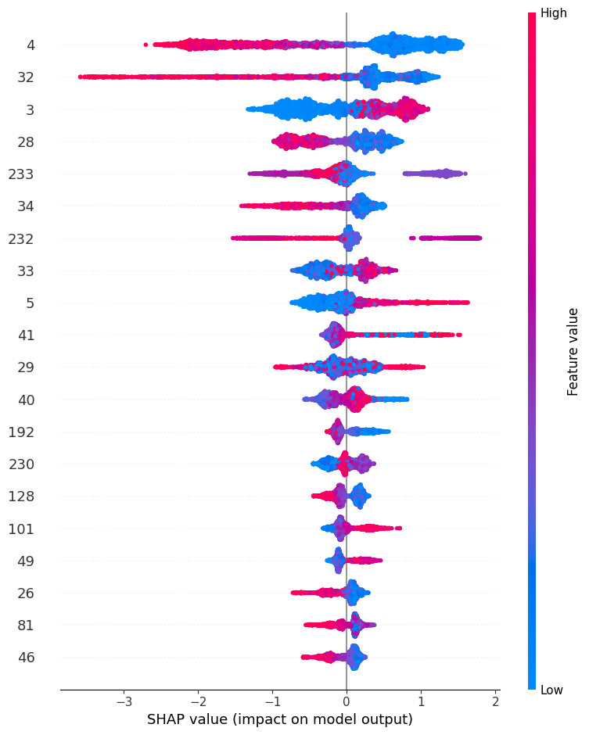
Fig. 3. SHAP summary plot showing mean absolute feature importance for the XGBoost classifer.

Conclusion and Future Directions
This research successfully developed an optimized system for guitar chord classification, focusing on the distinction between major and minor tonalities [1], [2], [6]. A 237-dimension feature space was created by integrating harmonic interval extraction via FFT [1], [5] with spectral features derived from the Librosa library [3], [4]. The soft-voting ensemble comprising Random Forest, Extra Trees and XGBoost [6], [9] was leveraged to achieve a mean cross-validation accuracy of 97.40% ± 0.60% [6].
This result represents a significant 3.4%-point improvement over the prior empirical studies [1], [2], [6], [11] with 94% baseline establishment that relied on higher-order harmonics alone [1], [5]. The study confirms that while harmonic intervals provide the foundational tonal structure [1], [2], the addition of spectral timbre descriptors like MFCCs and spectral contrast is essential for resolving ambiguities in raw audio [3], [4], [8]. Furthermore, the use of pipeline-based scaling and stratified cross-validation ensured that these results are statistically valid and free from data leakage [11], [17], providing a reliable framework for future Music Information Retrieval (MIR) applications [13], [14], [22], [23], [24].
Future research directions include extending the system to multi-class chord recognition beyond major/minor [2], [13], [15], integrating convolutional deep learning models for comparison [7], [8], and applying the Jaccard Similarity Index for further feature optimization [16]. Additional evaluations on Indian classical music benchmarks such as Tabla [15] and Raga classification [16] would assess cross-domain generalizability. Blockchain-based energy conservation frameworks [30] and smart contract security methods [28], [29] may further extend the trustworthiness of deployed MIR systems [25], [26]. Human-computer interaction and NLP extensions [21], [23], [24] are also promising directions [18], [19].

References
- [1] J. Guerrero-Turrubiates, S. Ledesma, S. González-Reyna, and G. Avina-Cervantes, “Guitar Chords Classification Using Uncertainty Measurements of Frequency Bins,” Mathematical Problems in Engineering, vol. 2015, 2015.
- [2] J. De Jesus Guerrero-Turrubiates et al., “Guitar audio signal classification by collapsed Pitch Class Profile,” in Proc. 2016 IEEE ROPEC, 2016, pp. 1–6.
- [3] F. Korzeniowski and G. Widmer, “Feature Learning for Chord Recognition: The Deep Chroma Extractor,” arXiv:1612.05065, 2016.
- [4] L. Sumarno, “The Performance of MFCC Feature Extraction for Guitar Chord Recognition,” in VII Int. Conf. Safety Problems of Civil Engineering Critical Infrastructures, 2023.
- [5] L. Sumarno, “Chord Recognition using FFT Based Segment Averaging and Subsampling Feature Extraction,” in Proc. 2020 8th Int. Conf. ICoICT, 2020, pp. 1–5.
- [6] S. Sharma et al., “Advanced Harmonic Feature Utilization in Ensemble Learning for Guitar Chord Classification,” in Proc. 2025 IEEE ICITEICS, 2025, pp. 1–6.
- [7] W. Tang and L. Gu, “Harmonic Classification with Enhancing Music Using Deep Learning Techniques,” Complex., vol. 2021, Art. no. 5590996, 2021.
- [8] Y. Wu and W. Li, “Automatic Audio Chord Recognition With MIDI-Trained Deep Feature and BLSTM-CRF Sequence Decoding Model,” IEEE/ACM Trans. Audio, Speech, Lang. Process., vol. 27, pp. 355–366, 2019.
- [9] T. Carsault, J. Nika, P. Esling, and G. Assayag, “Combining Real-Time Extraction and Prediction of Musical Chord Progressions for Creative Applications,” Electronics, 2021.
- [10] N. Monnier, D. Ghali, and S. Liu, “FFT and Machine Learning Application on Major Chord Recognition,” in Proc. 2021 ICUFN, 2021, pp. 426–429.
- [11] N. Sharma et al., “Comparative Analysis of Gaussian Naïve Bayes with Bernoulli Naïve Bayes for Guitar Chord Classification,” in Proc. 2024 PDGC, 2024, pp. 416–420.
- [12] K. R. Ahmed et al., “Empirical Analysis of Sigmoid Calibration on Gaussian Naïve Bayes Performance for Guitar Chords Classification,” in Proc. 2025 INCIP, 2025, pp. 293–297.
- [13] D. A. Talavera, E. Nase, L. Pancho, and A. Ilao, “Transcription of Guitar Chords from Acoustic Audio,” J. Advances Inf. Technol., 2020.
- [14] G. Byambatsogt, L. Choimaa, and G. Koutaki, “Guitar Chord Sensing and Recognition Using Multi-Task Learning and Physical Data Augmentation with Robotics,” Sensors, vol. 20, 2020.
- [15] S. S. Pscse et al., “Indian Classical Percussion Instrument Tabla Taal Classification using Fast Converging CNN,” 2025. doi: 10.1109/AIC.2025.105.
- [16] S. Sharma et al., “Analysis of Ablated Accuracy on Features in Carnatic Music Raga Classification with improved Jaccard Similarity Index,” in Proc. 2025 ICCAMS, 2025, pp. 1–7. doi: 10.1109/ICCAMS65118.2025.11233859.
- [17] N. Sharma et al., “Analysis of Isotonic Calibration on Gaussian Naïve Bayes Performance for Guitar Chords Classification,” in Proc. 2025 AUTOCOM, 2025, pp. 15–19. doi: 10.1109/AUTOCOM64127.2025.10956982.
- [18] N. Sharma et al., “Hyper Parametric Analysis of Multi-Layer Perceptron for Music Genre Classification,” in Proc. 2024 ICRISST, 2024, pp. 1–4. doi: 10.1109/ICRISST59181.2024.10921894.
- [19] S. Sharma et al., “Performance Analysis of FTRL algorithm for Dense and Deep Model of Music Mood Classification,” in Proc. 2024 ICRISST, 2024, pp. 1–4. doi: 10.1109/ICRISST59181.2024.10921949.
- [20] N. Sharma and S. Sharma, “A Customizable Mathematical Model for Determining the Difficulty of Guitar Triad Chords for Machine Learning,” in Lecture Notes in Networks and Systems, Springer, 2023, pp. 667–679. doi: 10.1007/978-981-99-2322-9_51.
- [21] N. Sharma and S. Sharma, “Optimization of t-SNE by Tuning Perplexity for Dimensionality Reduction in NLP,” in Proc. ICCCT, Springer, 2023, pp. 519–528. doi: 10.1007/978-981-99-3485-0_41.
- [22] S. Sharma et al., “Generative AI: A Review of Continuous Evolving Information Generation Perspective,” in AI Powered Cybersecurity for Banking and Finance, 2025, pp. 449–498.
- [23] N. Sharma and S. Sharma, “Natural Language Processing: A Study of State of the Art,” in AI-Centric Modeling and Analytics, CRC Press, 2023, p. 91.
- [24] N. Sharma and S. Sharma, “Human-Interacted Computation System: A State of the Art in Music,” in Heterogenous Computational Intelligence in IoT, CRC Press, 2024, pp. 1–17. doi: 10.1201/9781003363606.
- [25] J. Yadav, N. Garg, and N. Sharma, “Analysis of Packet Loss and Throughput in Heterogeneous MANETs over UDP,” Int. J. Sci. Eng. Res., vol. 4, no. 6, 2013.
- [26] N. Sharma, “Analysis of Security Requirements in Wireless Networks and MANETs,” GESJ: Comput. Sci. Telecommun., vol. 5, no. 28, 2010.
- [27] N. Sharma and S. Sharma, “Performance Enhancement of KNN Classifier for Guitar Chord Tonality Classification,” Indian J. Natural Sci., vol. 13, no. 76, pp. 53143–53148, 2023.
- [28] N. Sharma et al., “Solidity Smart Contract Vulnerabilities, Attack Scenarios, and Mitigation—A Survey,” in Proc. ICCCT, Springer, 2023, pp. 901–910. doi: 10.1007/978-981-99-3485-0_71.
- [29] N. Sharma and S. Sharma, “A Survey of Mythril, A Smart Contract Security Analysis Tool for EVM Bytecode,” Indian J. Natural Sci., vol. 13, no. 75, pp. 51003–51010, 2022.
- [30] S. R. Rammohan et al., “Systematic Survey on Energy Conservation Using Blockchain for Sustainable Computing Challenges and Roadmaps,” John Wiley and Sons Ltd., 2024. doi: 10.1002/acs.3948.

